

COURSE TITLE: **ADDITIVE MANUFACTURING AND PRODUCTION SYSTEMS**

GUIDED BY – Prof. ALBERTO BOSCHETTO

**EXERCISE-2**

**COMPUTER AIDED MANUFACTURING**

**GROUP NUMBER: 10**

|  |  |
| --- | --- |
| VARUN YASHWANT RASALKAR | **1921452** |
|  |  |
|  |  |

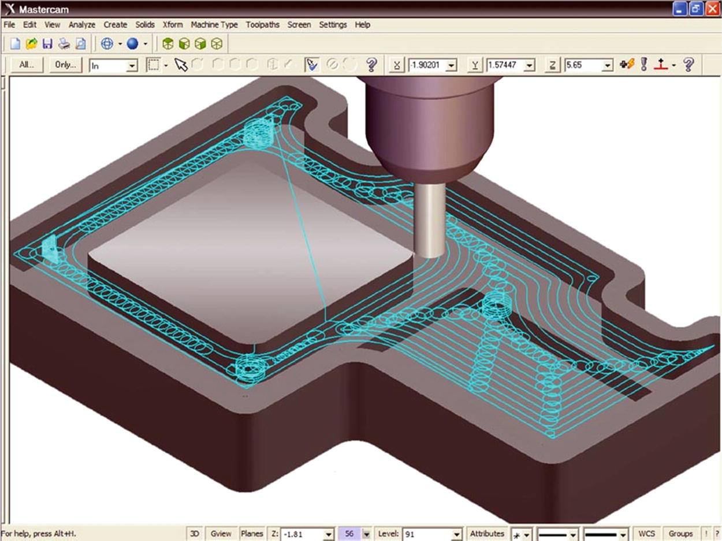

**COMPUTER AIDED MANUFACTURING**

**Part A**

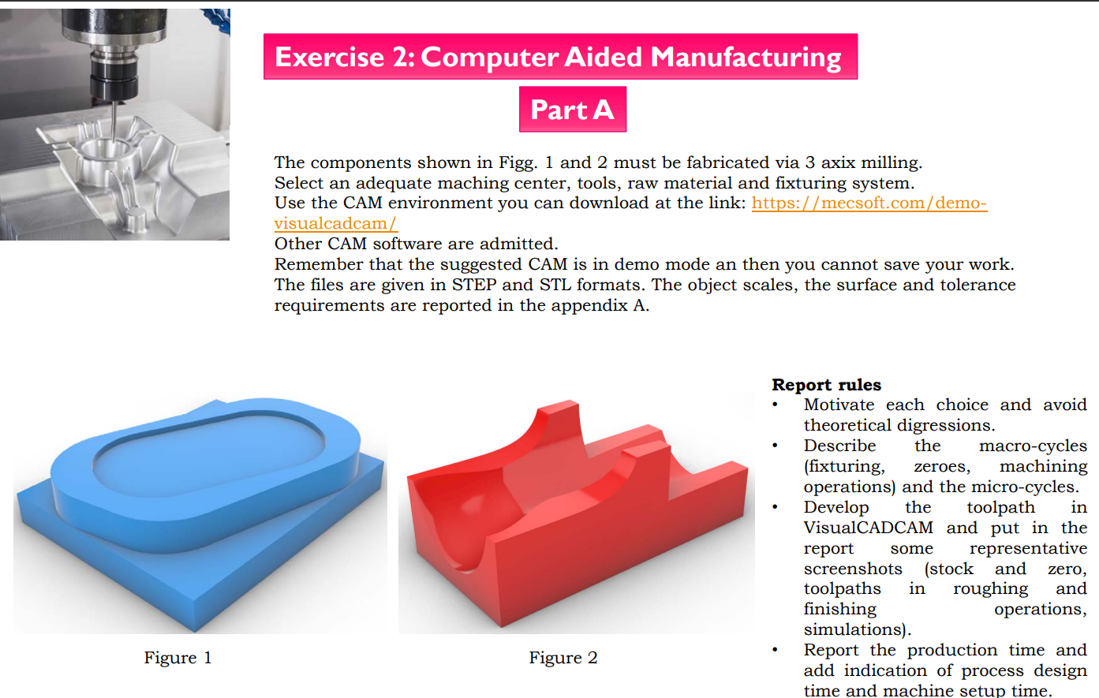

**Machine setup**:

As per instructions we are using 3 axis milling machine which includes horizontal roughing and parallel finishing procedure in the suggested interface Mecsoft VisualCAM 2022. Both machining solid parts are ABS.

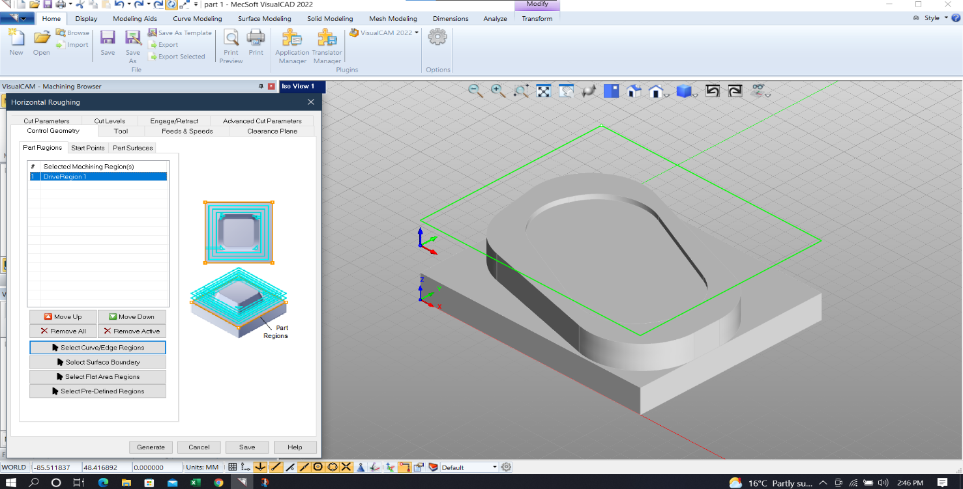

**Figure**:**1**

**Scale:**

We uniformly Scaled the given parts as given in chart for part 1 and part 2 are 110% (1.1) and 90% (0.9) respectively.

**Stock setup**:

We are Setting up box stock



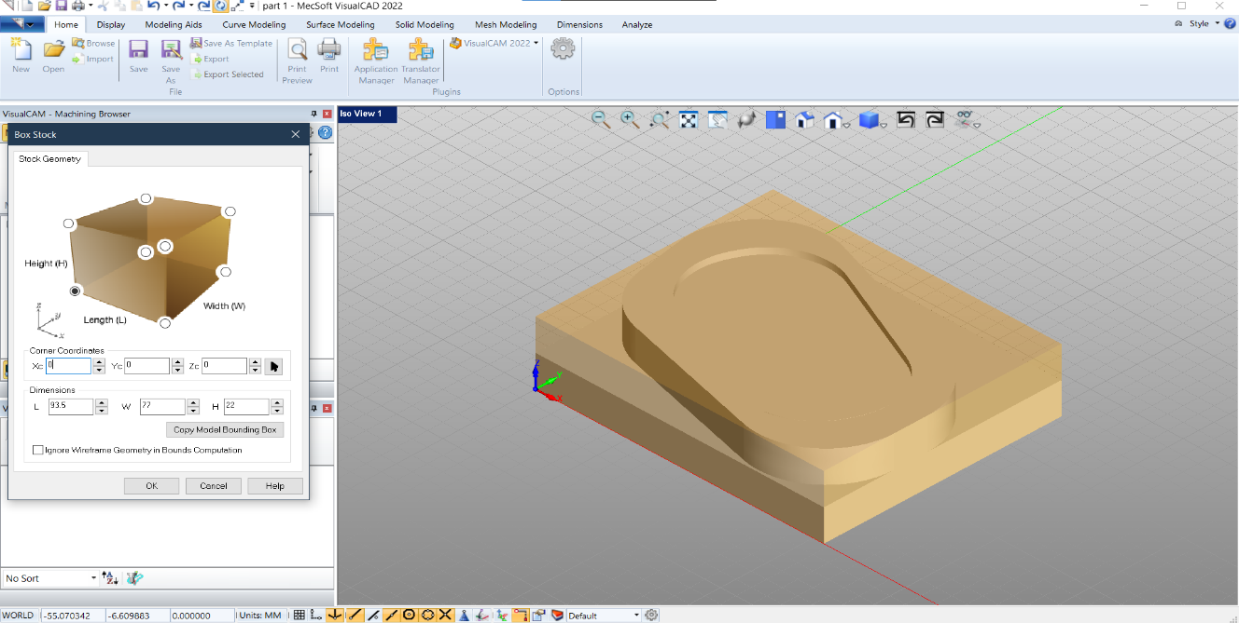

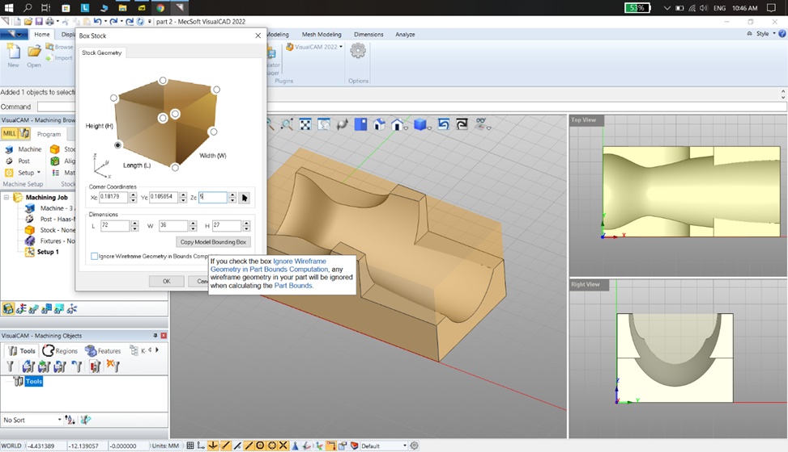

**Work Zero:**

Setting work zero as given in below

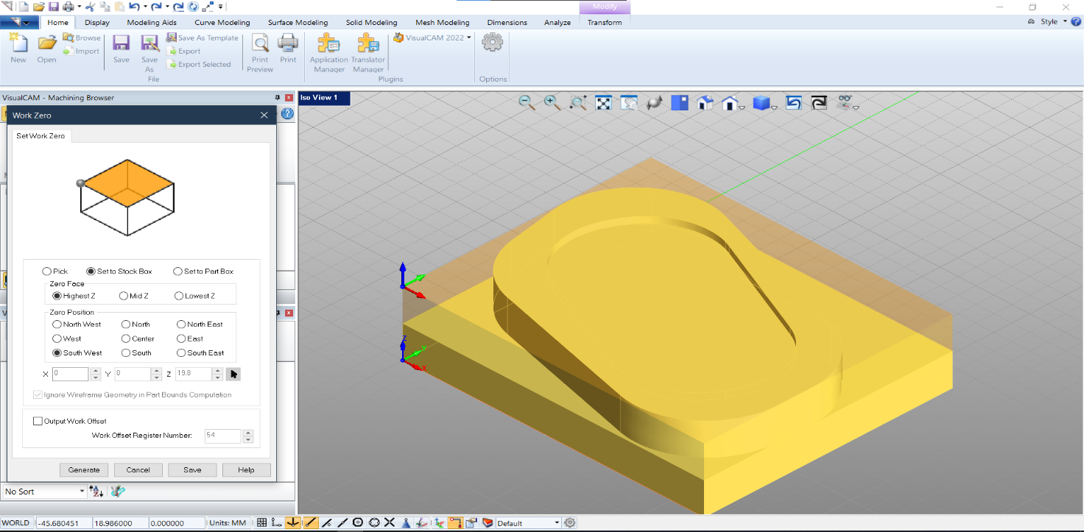

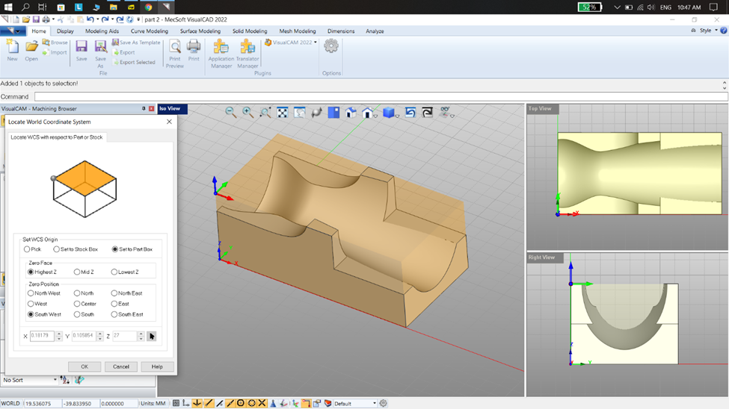

After work zero selecting perfect tool for roughing and finishing operations for both part 1&2

**Tool selection:**

Carbide Tool 1 flat mill with 4mm diameter and 3 flutes

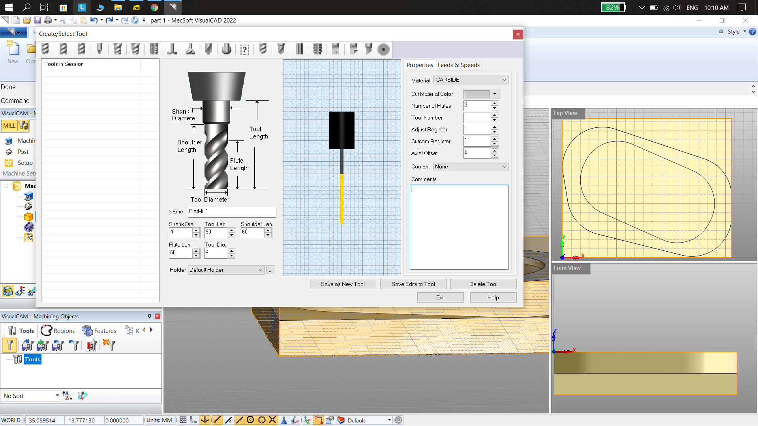

Carbide Tool 2 flat mill with 4mm diameter and 4 flutes

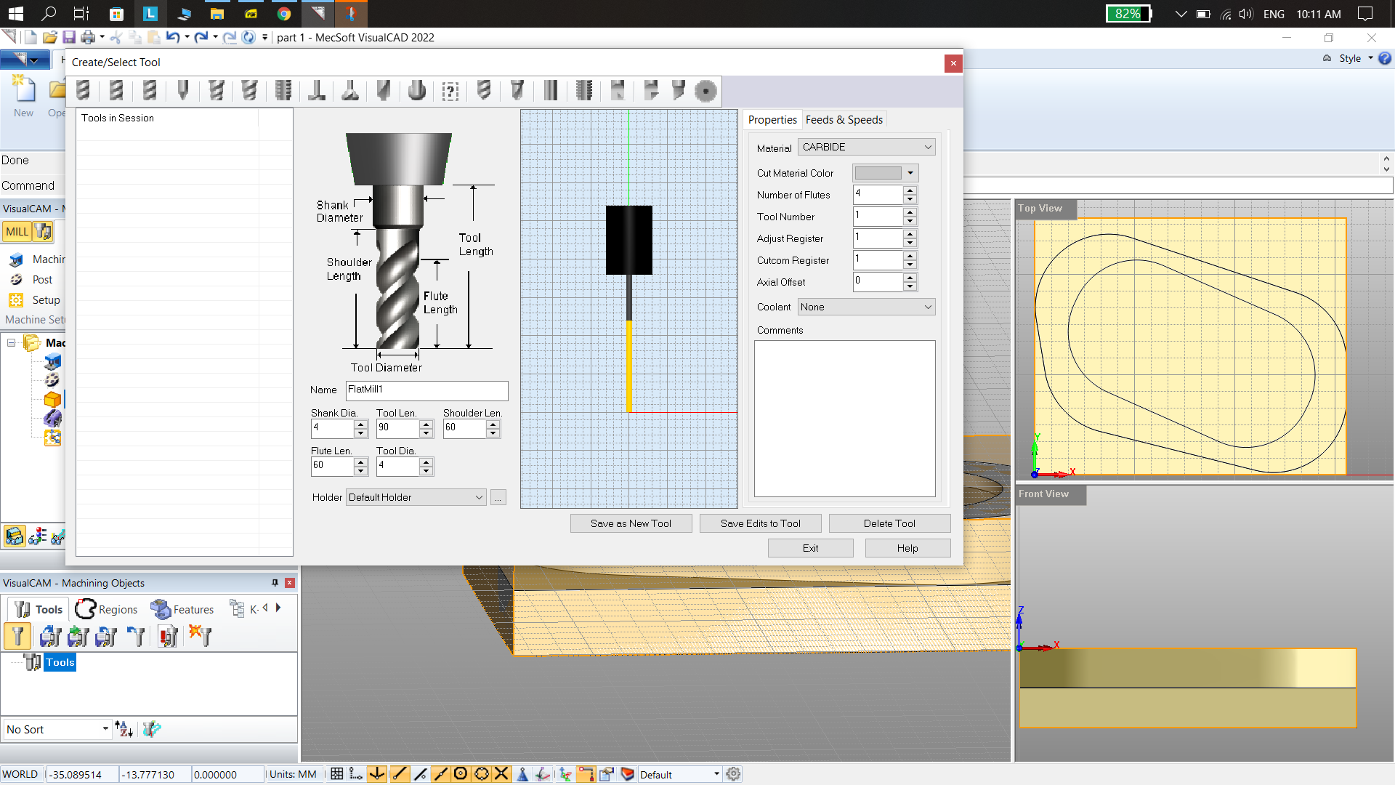

Carbide Tool 3 ball mill with 2mm diameter and 4 flutes

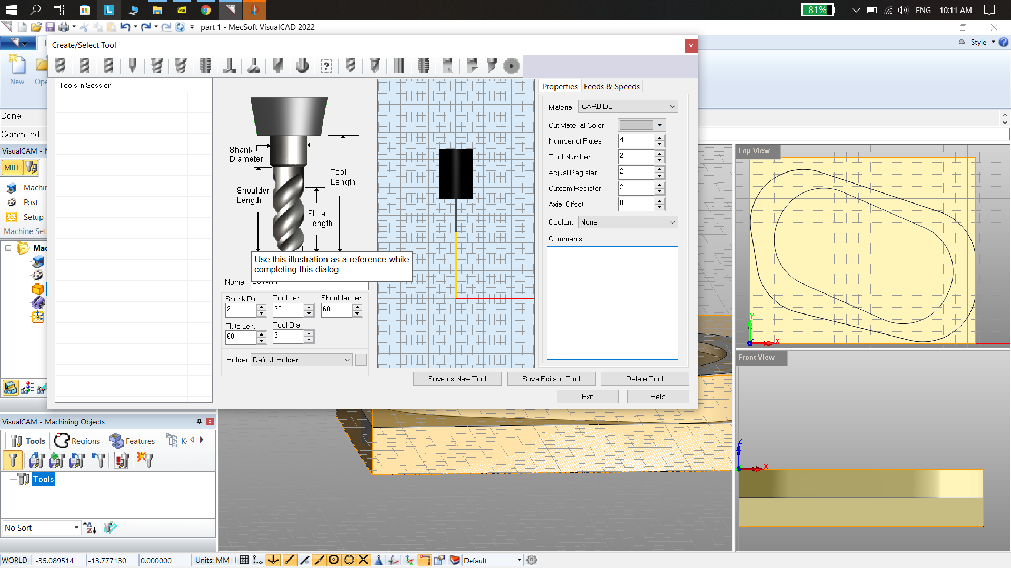

**Horizontal roughing:**

In horizontal roughing first we select the drive region to make sure that our tool doesn’t move out of the stock this is done basically to make sure the tool doesn’t hit the fixture, even though in the operation we aren’t using any fixtures but me make sure the drive region is limited to stock. As shown in figure 1.

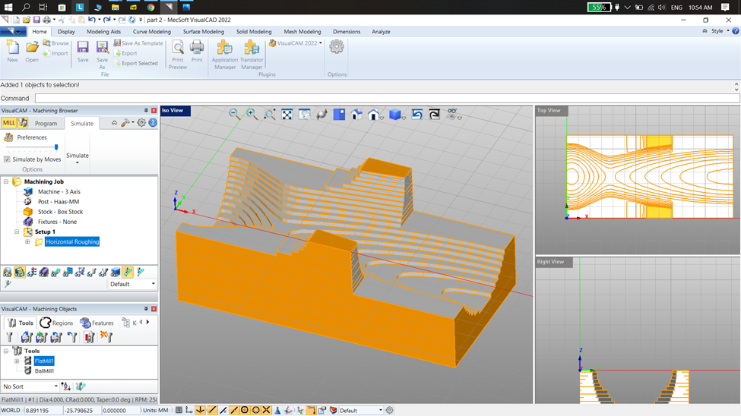

**Feed and speed:**

After the tool selection we tried with default values due to unsatisfactory outcome we customized the values to get optimal outcome.

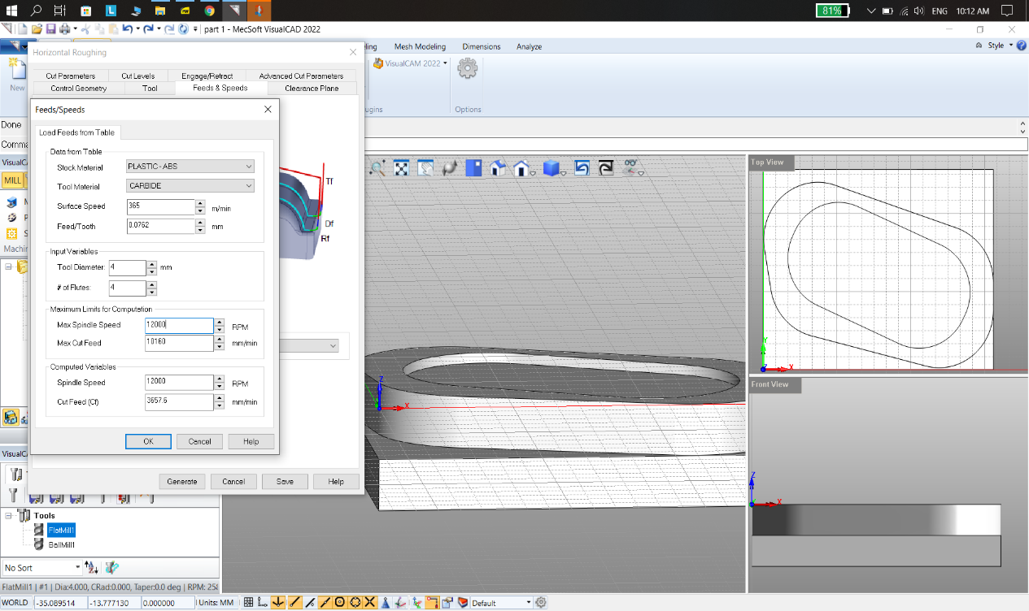

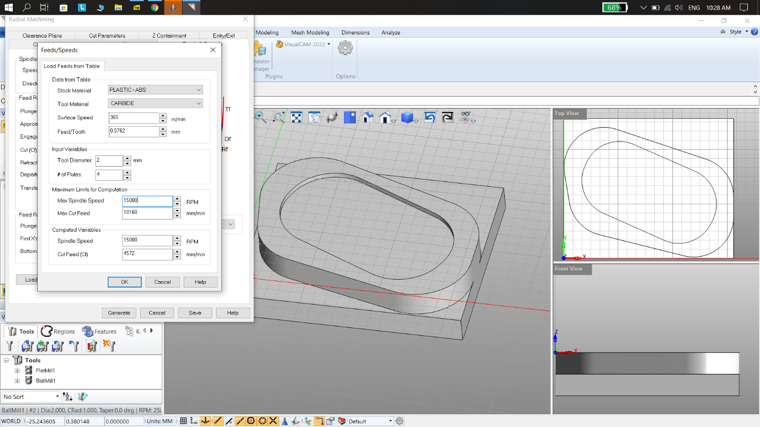

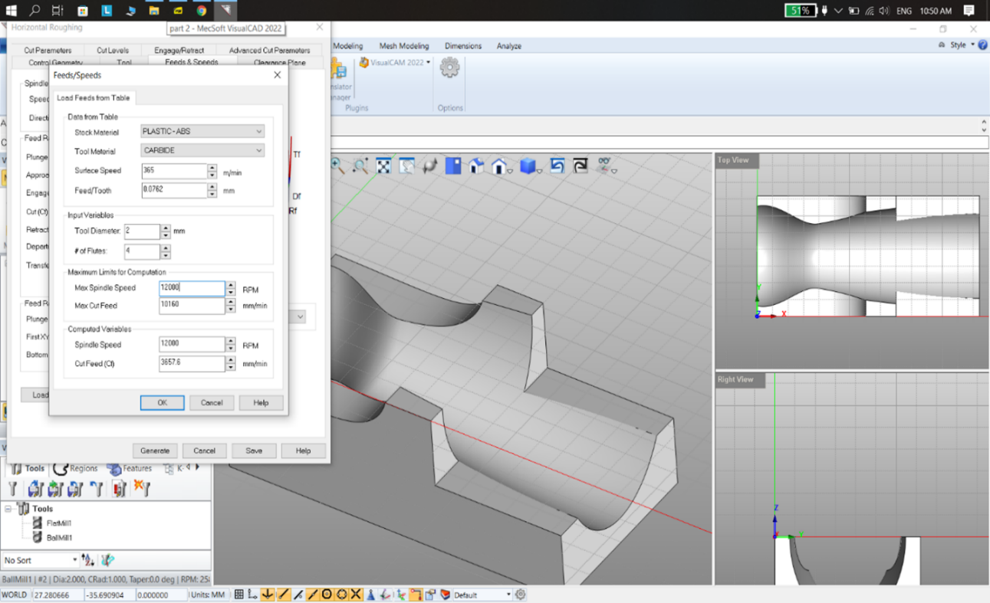

Cut levels and advanced parameters for roughness and tolerances of ABS material for better surface finishing.

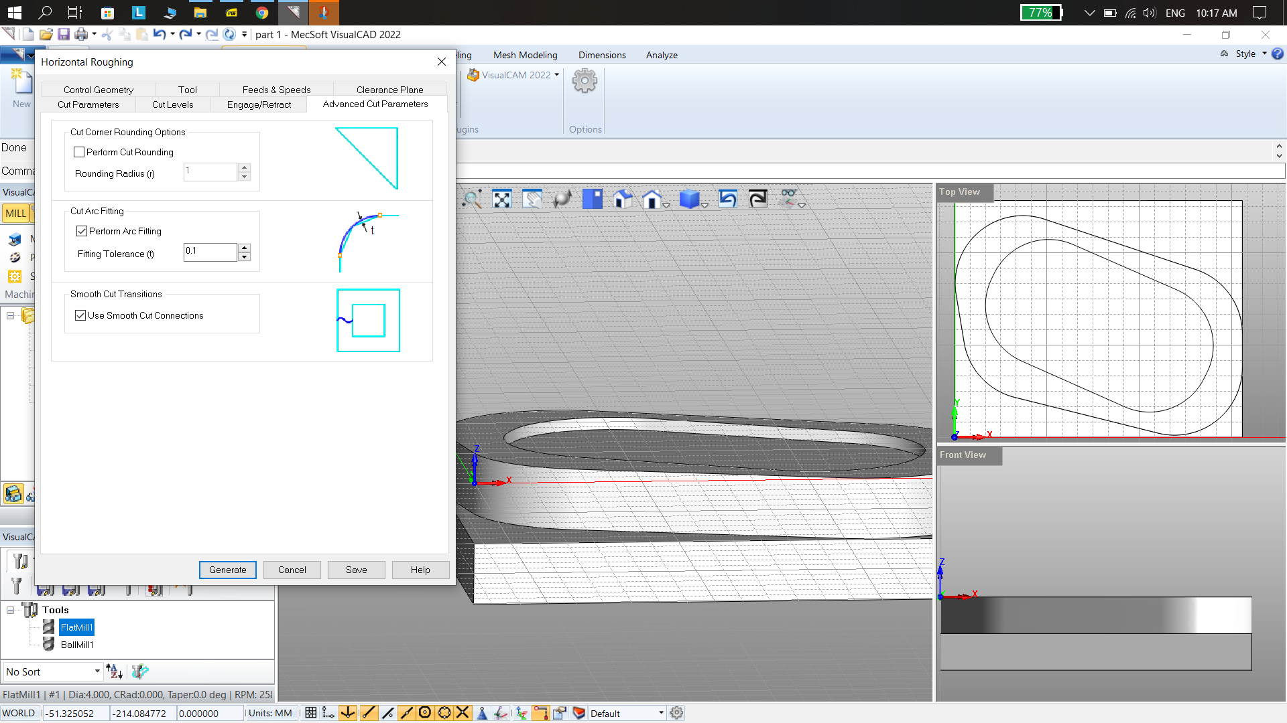

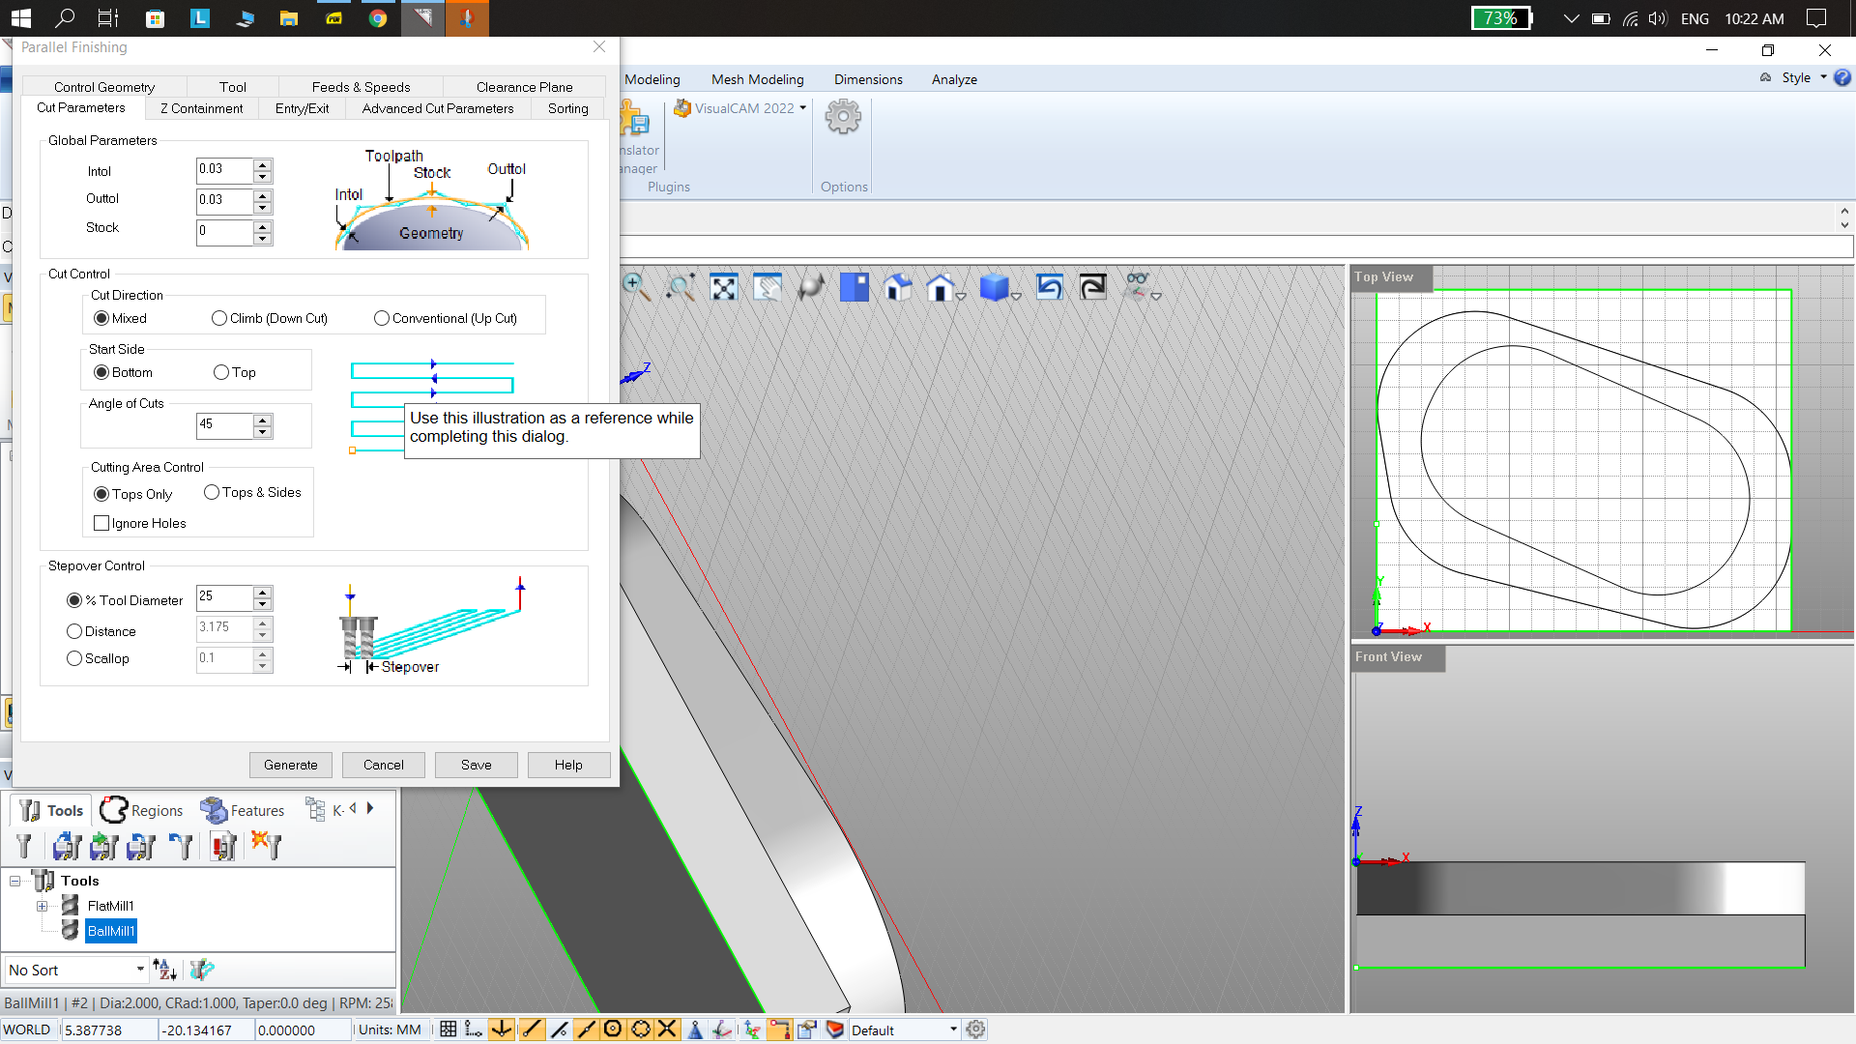

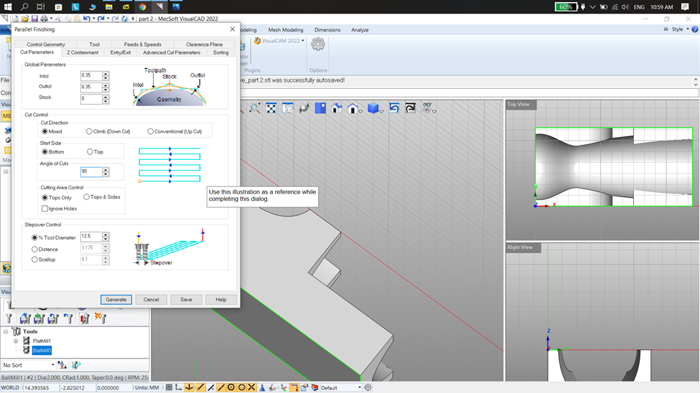

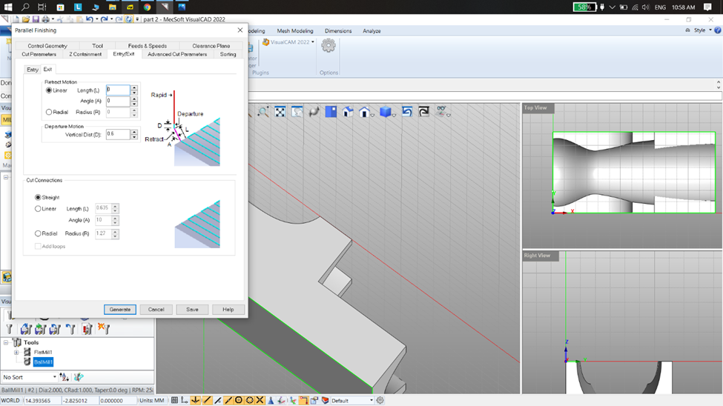

After horizontal roughing selecting parallel finishing for better finishing as shown in below figure

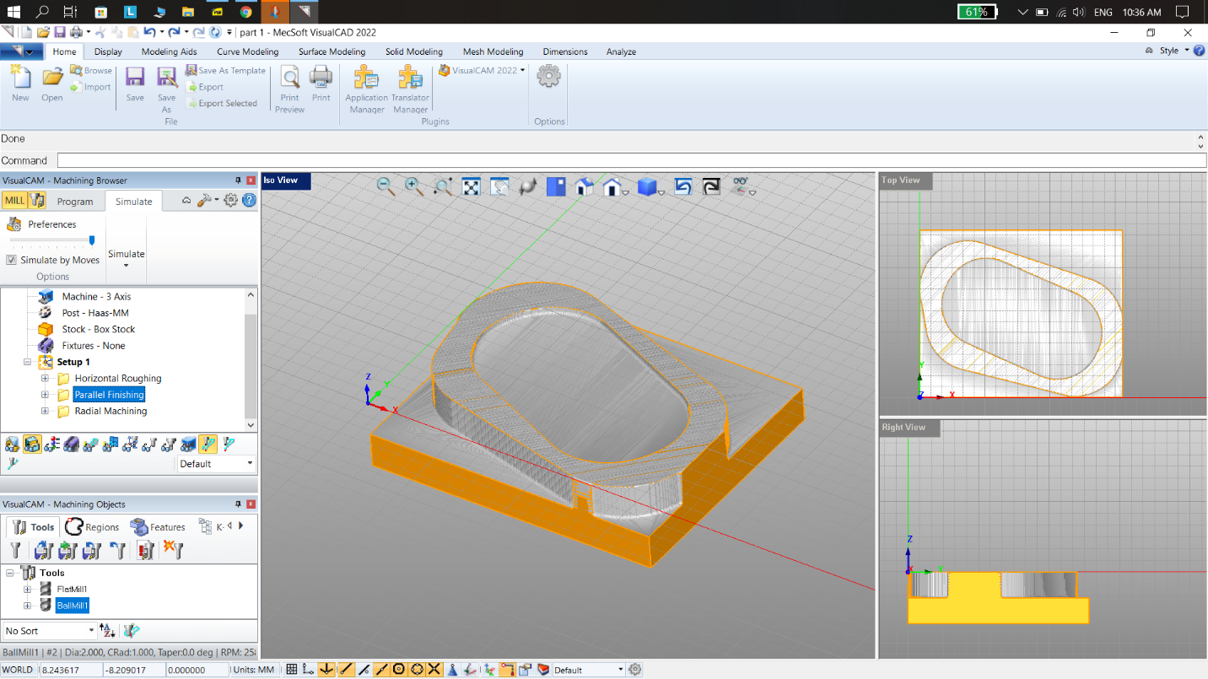

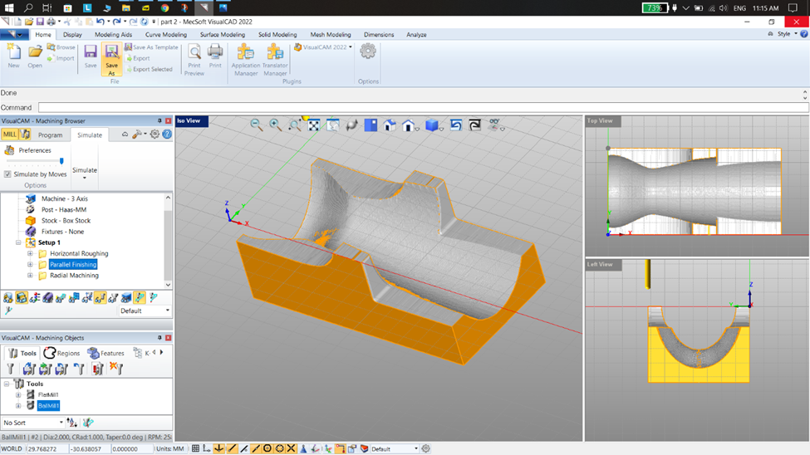

After parallel finishing considering radial machining

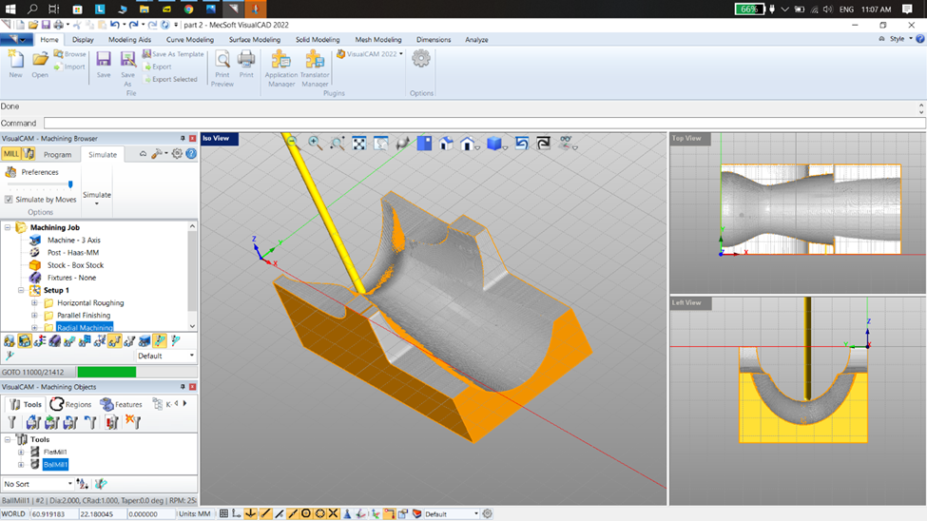

Total time taken for the machining process is given below

for part 1

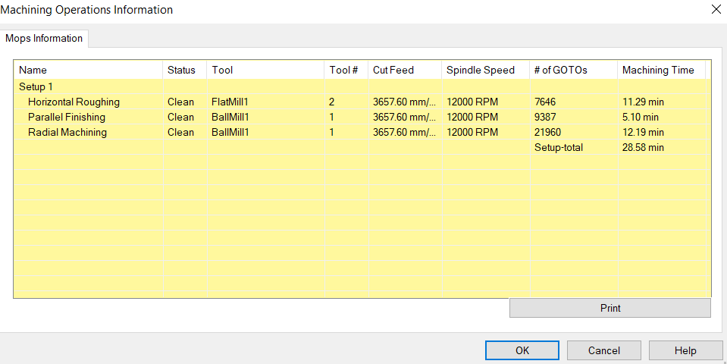

|  |  |
| --- | --- |
| **Operations** | **Time**  **(Hours)** |
| Process design | 0.10 |
| Machine setup | 0.20 |
| Micro cycle | 0.15 |
| Macro cycle | 0.40 |
| Stock setting | 0.10 |
| Zero setting | 0.10 |
| Total machining time (production) | 0.28 |

**So total time taken for one part (1) is 2.21**

**Raw material for one part = 127 grams**

**Cost of experienced CAM operator per hour = 15 euros**

**Total cost of time = 2.21 x 15 = 33.25 euros**

**Cost of raw material (ABS) for 1 part = 0.19 euros (1kg = 1.5 euros)**

**Total cost per part = 33.44 euros**

**Total time taken for machining part 2**

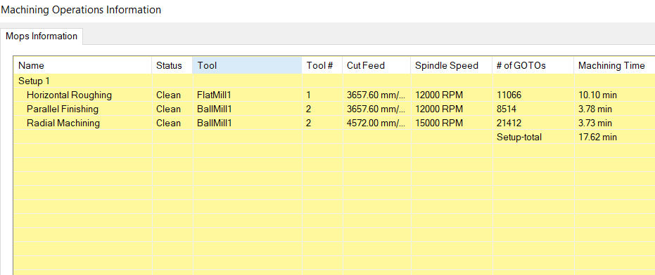

|  |  |
| --- | --- |
| **Operations** | **Time**  **(Hours)** |
| Process design | 0.10 |
| Machine setup | 0.20 |
| Micro cycle | 0.10 |
| Macro cycle | 0.40 |
| Stock setting | 0.10 |
| Zero setting | 0.10 |
| Total machining | 0.17 |

**So total time taken for only one part (2) is 2.1 hours**

**Raw material for one part = 34 grams**

**Cost of experienced CAM operator per hour = 15 euros**

**Total cost of time = 2.1 x 15 = 31.5 euros**

**Cost of raw material (ABS) for 1 part = 0.051 euros (1kg = 1.5 euros)**

**Total cost per part = 31.5 euros**

**Total time and cost for machining 10 parts (both part1&2):**

|  |  |  |
| --- | --- | --- |
| **PART 1** | **CAM(TIME)** | **CAM COST (EUROS)** |
| **P1** | **2.21** | **33.44** |
| **P2** | **4.42** | **66.88** |
| **P3** | **6.63** | **100.32** |
| **P4** | **8.84** | **133.76** |
| **P5** | **11.05** | **167.2** |
| **P6** | **13.26** | **200.64** |
| **P7** | **15.47** | **234.08** |
| **P8** | **17.68** | **267.52** |
| **P9** | **19.89** | **300.96** |
| **P10** | **22.1** | **334.4** |

|  |  |  |
| --- | --- | --- |
| **PART 2** | **CAM(TIME)** | **CAM COST(EUROS)** |
| **P1** | **2.1** | **31.5** |
| **P2** | **4.2** | **63** |
| **P3** | **6.3** | **94.5** |
| **P4** | **8.4** | **126** |
| **P5** | **10.5** | **157.5** |
| **P6** | **12.6** | **189** |
| **P7** | **14.7** | **220.5** |
| **P8** | **16.8** | **252** |
| **P9** | **18.9** | **283.5** |
| **P10** | **21** | **315** |

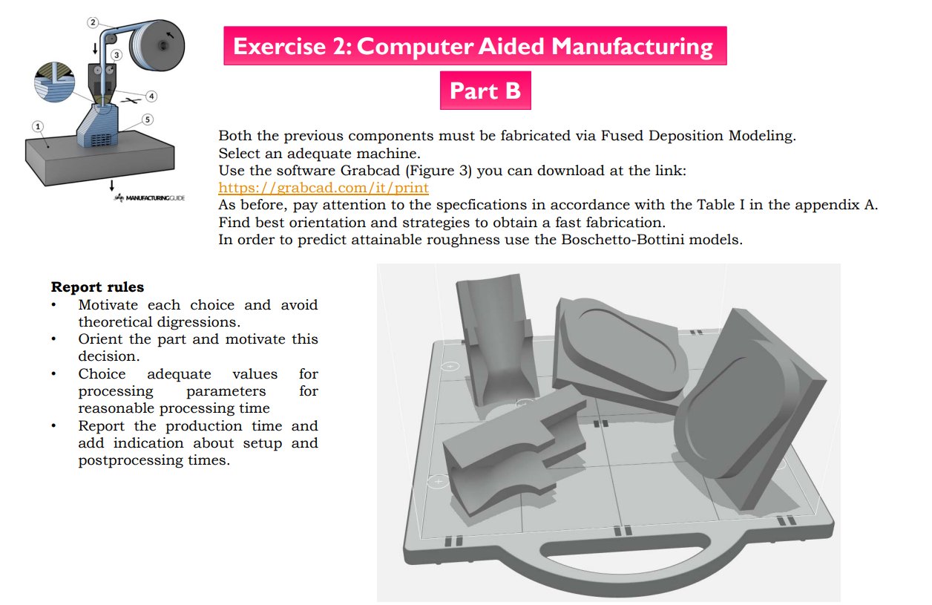

**3D Printer Machine Selection:**

We are selecting Stratasys F900 due to its widely usage in FDM market and accuracy.

**Model Material:**

The considered printing material is ABS also known as acrylonitrile butadiene styrene; ABS is one of the most versatile materials available for 3D printing today. ABS comes in the form of a long filament wound around a spool. The 3D Printing process used with ABS is the FDM (Fusion Deposition modelling) process where material is heated and squeezed through a fine nozzle to build your design in 250-micron layers.

3D printing Process Includes,

**Tray Setting**:

According to the printer we are considering Slice height as 0.254 mm for better surface finish

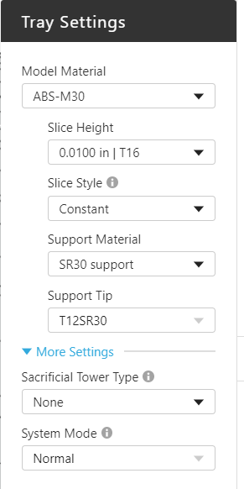

**Model settings**:

The body of both part 1 and part 2 both require better structural integrity, so we selected solid model

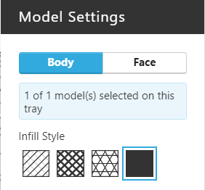

**Part 1 & part 2 slicing preview of all 20 parts of part 1 &2:**

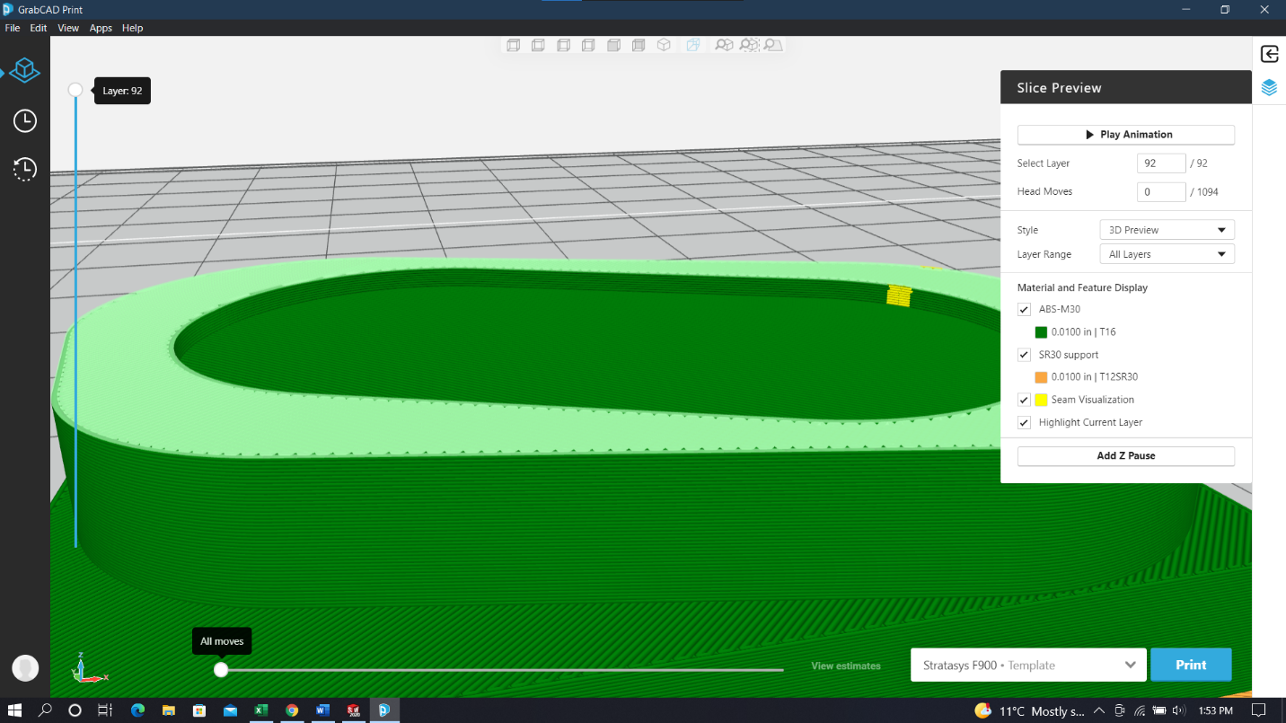

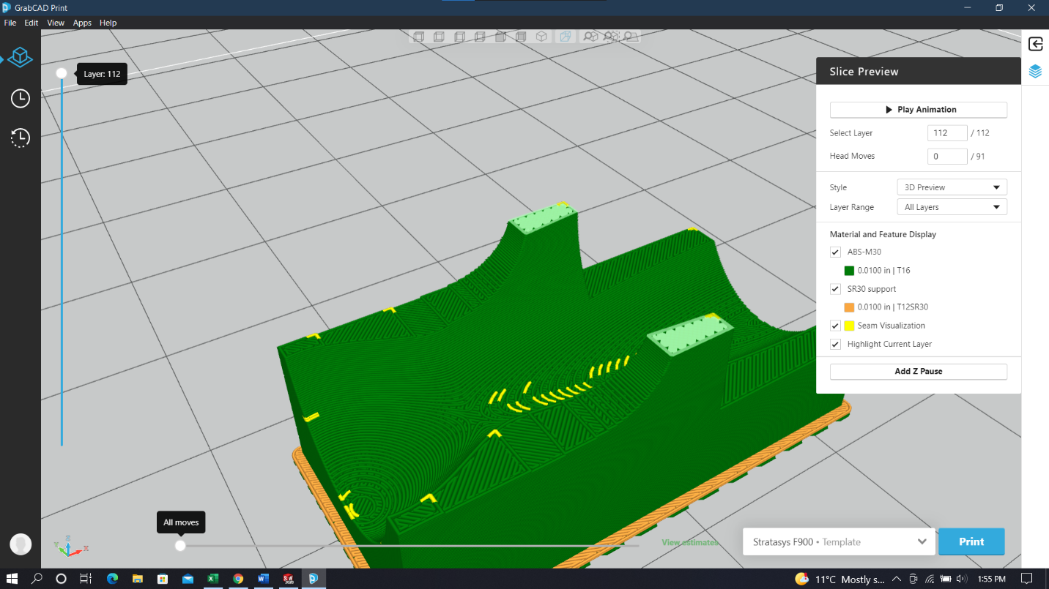

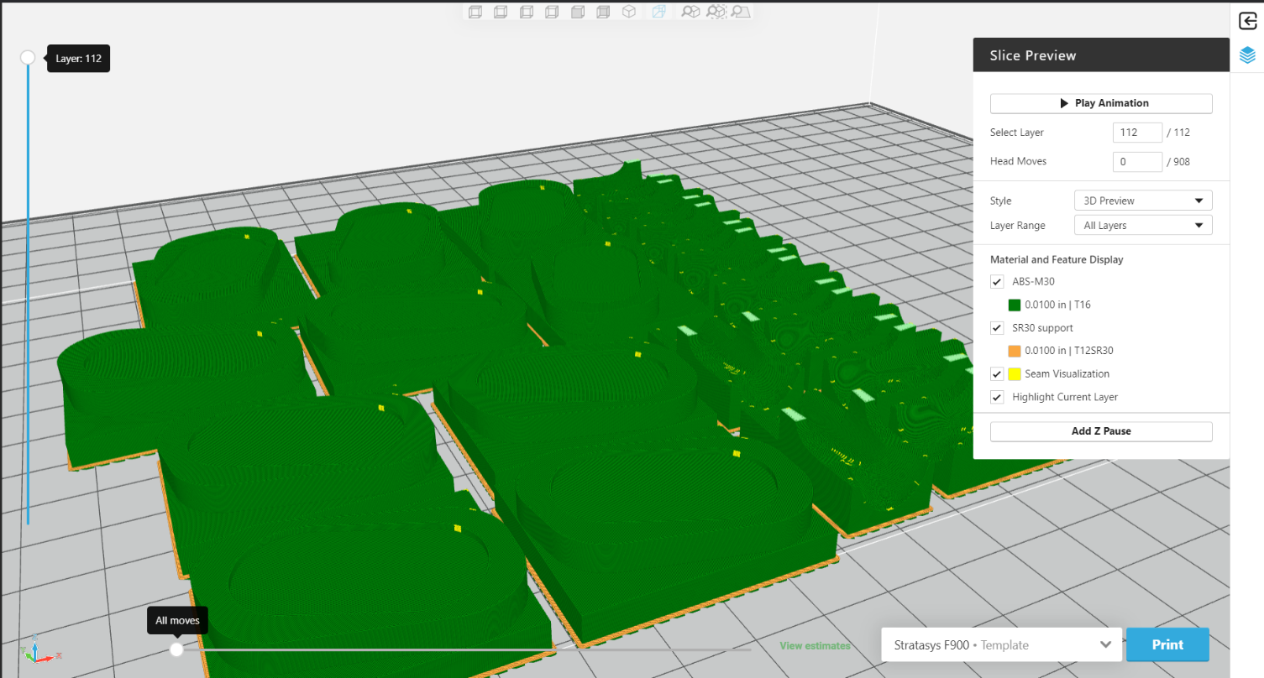

**Support settings:**

As we set support style in basic also base style is both model and support and self-supporting angle is 45 degrees, industrially it may vary for better surface finish and time consumption.

**Orientation:**

Orientationof model is default 90 degrees, but it can be changed for better outcome.

**Post Processing:**

The support layer present under both part 1 and part 2 can be removed by chipping and the printed part does not support the required roughness to compensate that the part is subjected to ABS acetone Vapor smoothing. The part is subjected to acetone fumes, the surface layer of the part gets melted due to acetone and the gap between the overlapped layers is filled with the melted material of the subsequent layers.

Therefore, the required surface roughness is achieved. The part should not be subjected for more time in acetone fumes else the dimensional deformation occurs; it must be given the required dwell time.

**Total cost and time taken for printing part 1 & 2**

|  |  |
| --- | --- |
| **Operations** | **Time**  **(Hours)** |
| Process design | 0.10 |
| Printer setup | 0.10 |
| Micro cycle | 0.15 |
| Macro cycle | 0.30 |
| Stock setting | 0.10 |
| Zero setting | 0.10 |
| Production time | 26.39 |

|  |  |
| --- | --- |
| **PART 1** | **3D PRINTING(TIME)** |
| **P1** | **4.2** |
| **P2** | **8.4** |
| **P3** | **12.6** |
| **P4** | **16.8** |
| **P5** | **21** |
| **P6** | **25.2** |
| **P7** | **29.4** |
| **P8** | **33.6** |
| **P9** | **37.8** |
| **P10** | **42** |

**Total time taken to produce per part 1 = 3.8**

**Cost of raw material per part 1 (0.127 kg) = 0.254 euros (1kg = 2 euros)**

**Cost of 3D printing operator per hour = 10 euros (Don’t need to be experienced)**

**Total time = 10x 3.8 = 38**

**Total cost = 38.254 euros**

|  |  |
| --- | --- |
| **PART 2** | **3D PRINTING(TIME)** |
| **P1** | **2.8** |
| **P2** | **4.8** |
| **P3** | **6.8** |
| **P4** | **8.8** |
| **P5** | **10.8** |
| **P6** | **12.8** |
| **P7** | **14.8** |
| **P8** | **16.8** |
| **P9** | **18.8** |
| **P10** | **20.8** |

**Total time taken to produce per part 2 = 2 hours**

**Cost of raw material per part 2 (0.038 kg) = 0.076 euros (1kg = 2 euros)**

**Cost of 3D printing operator per hour = 10 euros (Don’t need to be experienced)**

**Total time = 10x 2 =20**

**Total cost = 20 euros**

**Total Time for printing all 20 parts (part 1&2) is about 55.7hours**

**Total time and cost for machining 10 parts (both part 1&2):**

|  |  |  |
| --- | --- | --- |
| **PART 1** | **3D PRINTING(TIME)** | **3D PRINTING COST (EUROS)** |
| **P1** | **4.2** | **38.25** |
| **P2** | **8.4** | **76.5** |
| **P3** | **12.6** | **114.75** |
| **P4** | **16.8** | **153** |
| **P5** | **21** | **191.25** |
| **P6** | **25.2** | **229.5** |
| **P7** | **29.4** | **267.75** |
| **P8** | **33.6** | **306** |
| **P9** | **37.8** | **344.25** |
| **P10** | **42** | **382.5** |

|  |  |  |
| --- | --- | --- |
| **PART 2** | **CAM COST(EUROS)** | **3D PRINTING COST (EUROS)** |
| **P1** | **31.5** | **20** |
| **P2** | **63** | **40** |
| **P3** | **94.5** | **60** |
| **P4** | **126** | **80** |
| **P5** | **157.5** | **100** |
| **P6** | **189** | **120** |
| **P7** | **220.5** | **140** |
| **P8** | **252** | **160** |
| **P9** | **283.5** | **180** |
| **P10** | **315** | **200** |

**Technology comparison**

**Part C**

**Technology comparison:**

According to the below given data in table and graph, we did not find breakeven point, both technologies have their own advantages and disadvantages, there are some sensitive parameters taken consider in both preprocessing and postprocessing.

|  |  |  |
| --- | --- | --- |
| **PART 1&2** | **CAM COST(EUROS)** | **3D PRINTING COST (EUROS)** |
| **P1** | **64.94** | **58.25** |
| **P2** | **129.88** | **116.5** |
| **P3** | **194.82** | **174.75** |
| **P4** | **259.76** | **233** |
| **P5** | **324.7** | **291.25** |
| **P6** | **389.64** | **349.5** |
| **P7** | **454.58** | **407.75** |
| **P8** | **519.52** | **466** |
| **P9** | **584.46** | **524.25** |
| **P10** | **649.4** | **582.5** |